****Tarlac State University

**COLLEGE OF COMPUTER STUDIES**

Case Study

in

Integrative Programming Technology 2

Submitted By:

**FERNANDEZ, Cyrus Ortega**

**LAXAMANA, RYAN**

**LEONES, John Alvin Ferrer**

**QUIAMBAO, Elson Jr. Simbillo**

Submitted To:

**Millet, Axel D.**

Date: []

# **Case Analysis (Git and GitHub Workflow)**

## **Laxamana Documentation**

### **Remote Repository (GitHub) Creating a Milestone**

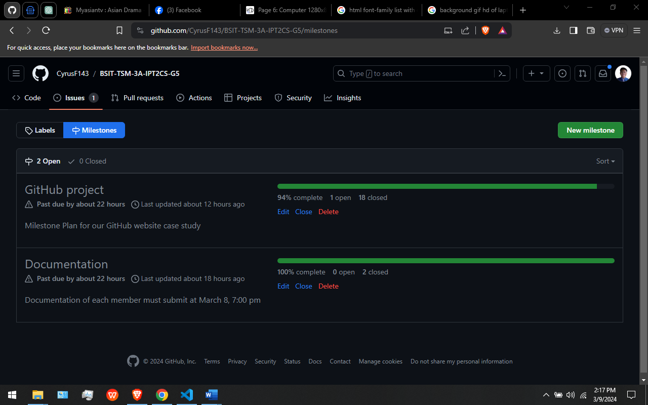

In this Figure. This are the milestone that our leader have created.

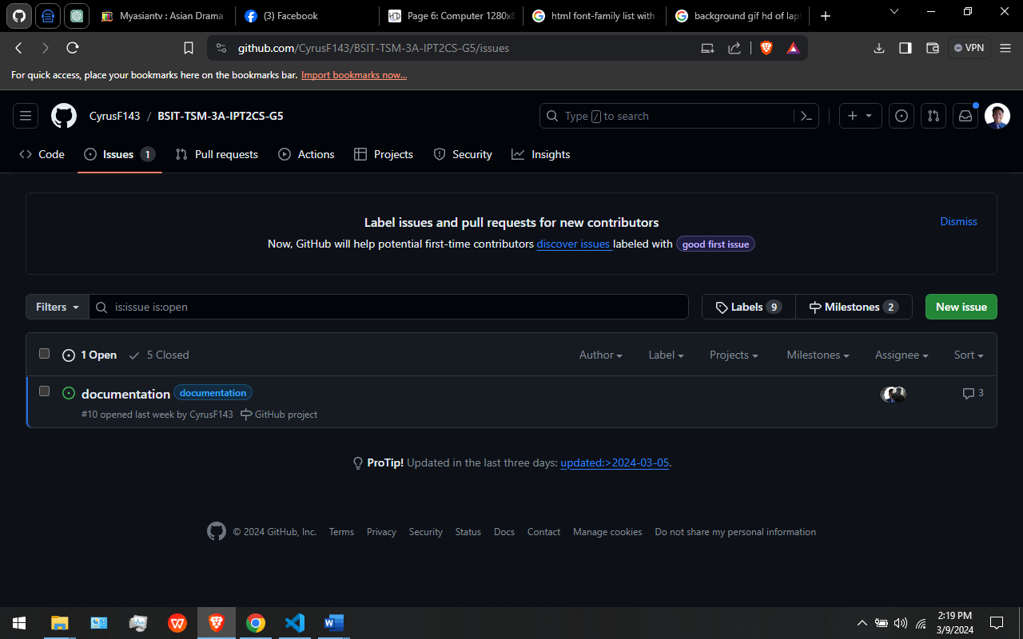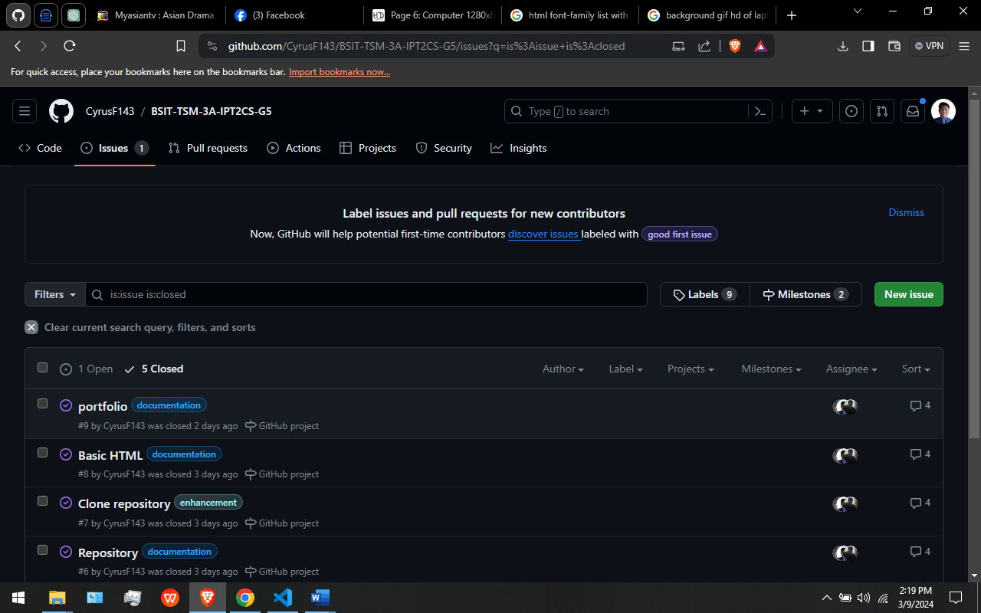

In this Figure. This are the Issues that are currently open and closed.

### **Local Repository (Git)**

**CLONING THE REMOTE REPOSITORY IN MY LOCAL REPOSITORY USING GITBASH**

**GIT CLONE:** Git Clone Command, “git clone” is a Git command line utility which is used to target an existing repository and create a clone, or copy of the target repository [10].

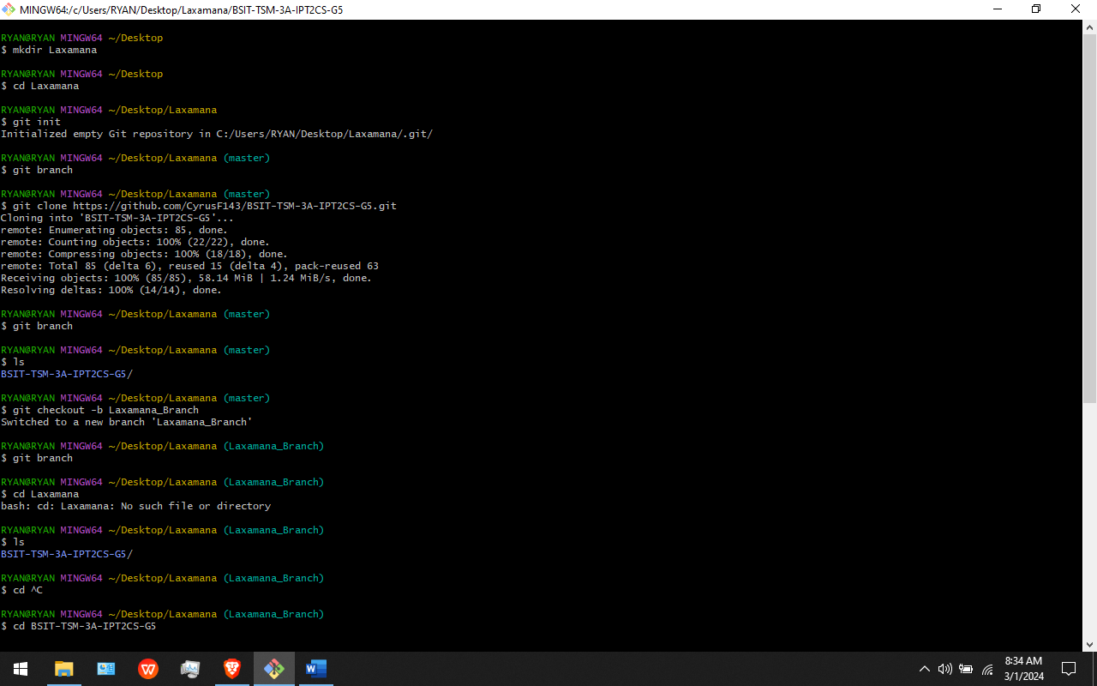

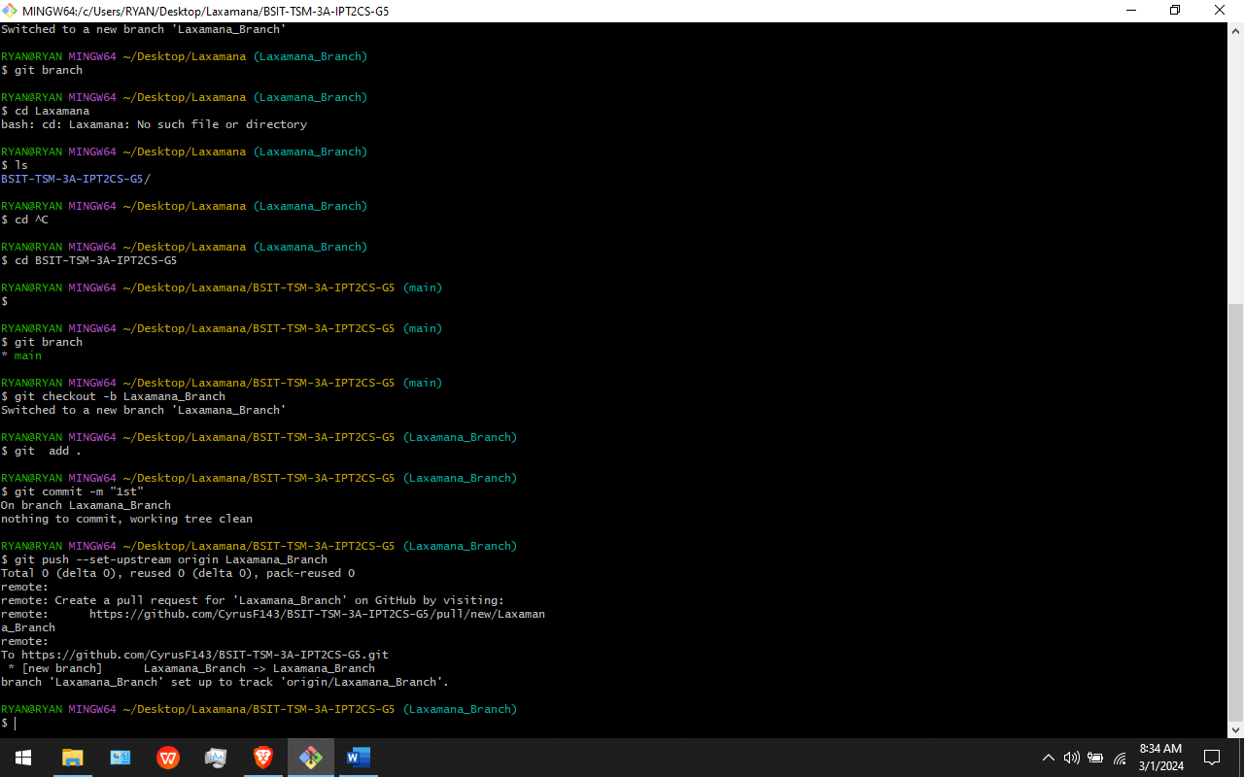

In this Figure: I Successfully Create a Folder, Cloning the Remote repository, Creating my Own Branch and Pushing my Branch to the github. I use git clone command to clone/copy the remote repository.

**GIT PULL:** The git pull command is used to fetch and download content from a remote repository and immediately update the local repository to match that content [14].

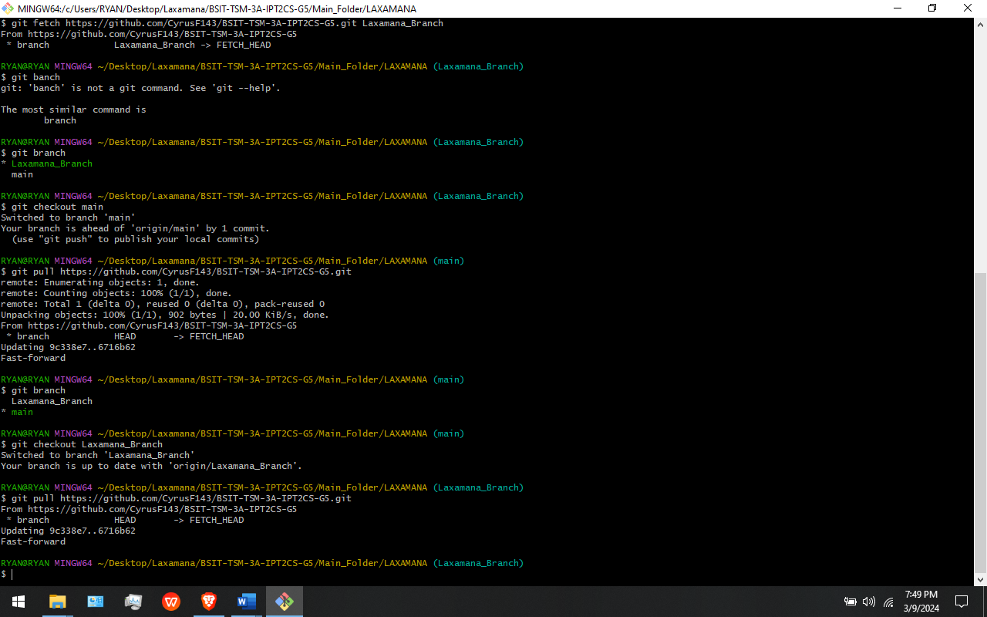

In This Figure: I use the command “git pull” to download all the files in the remote repository into the local repository.

**GIT PUSH:** Git push origin will push the current branch to the branch of the matching name in the remote repository. [7]



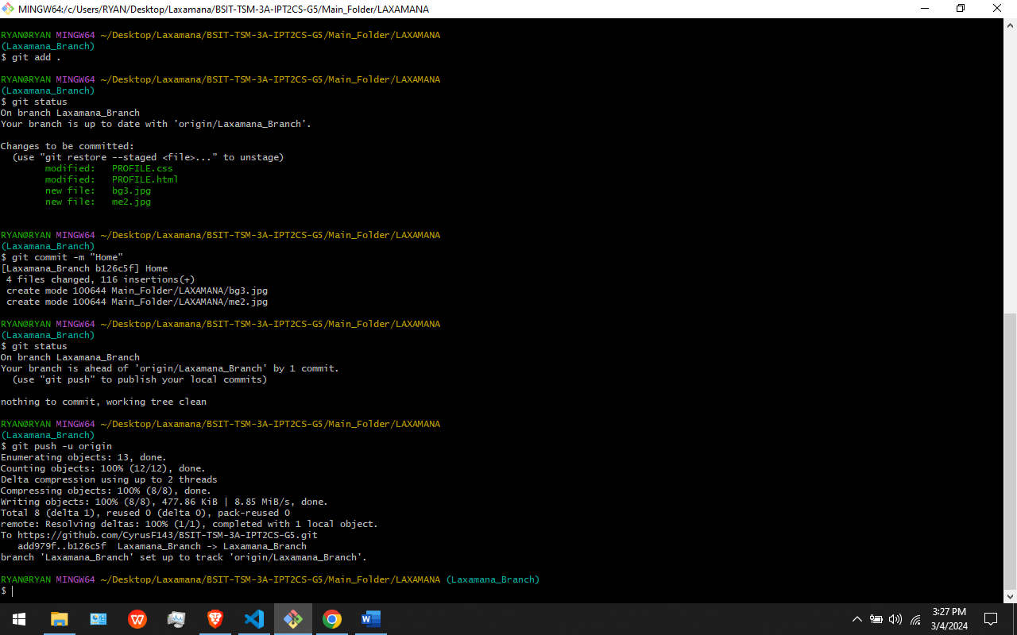

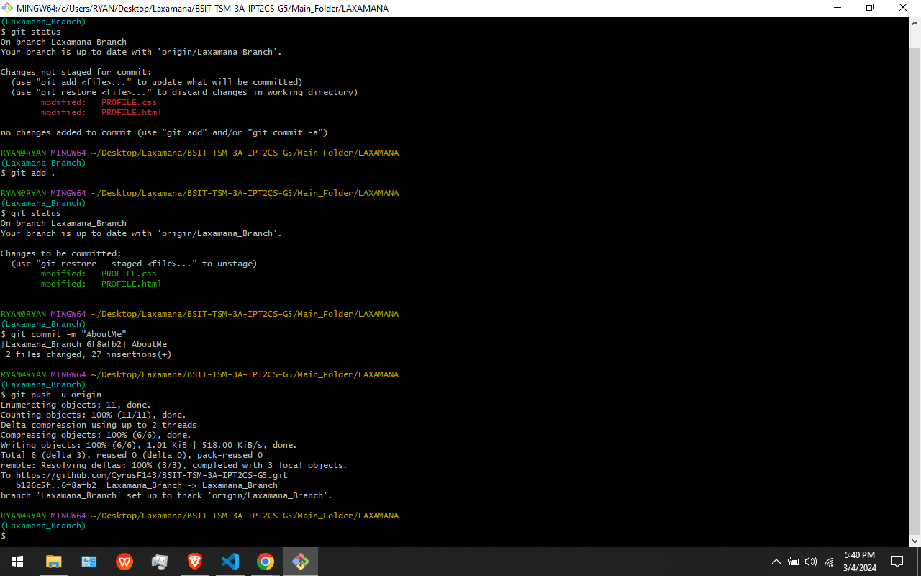

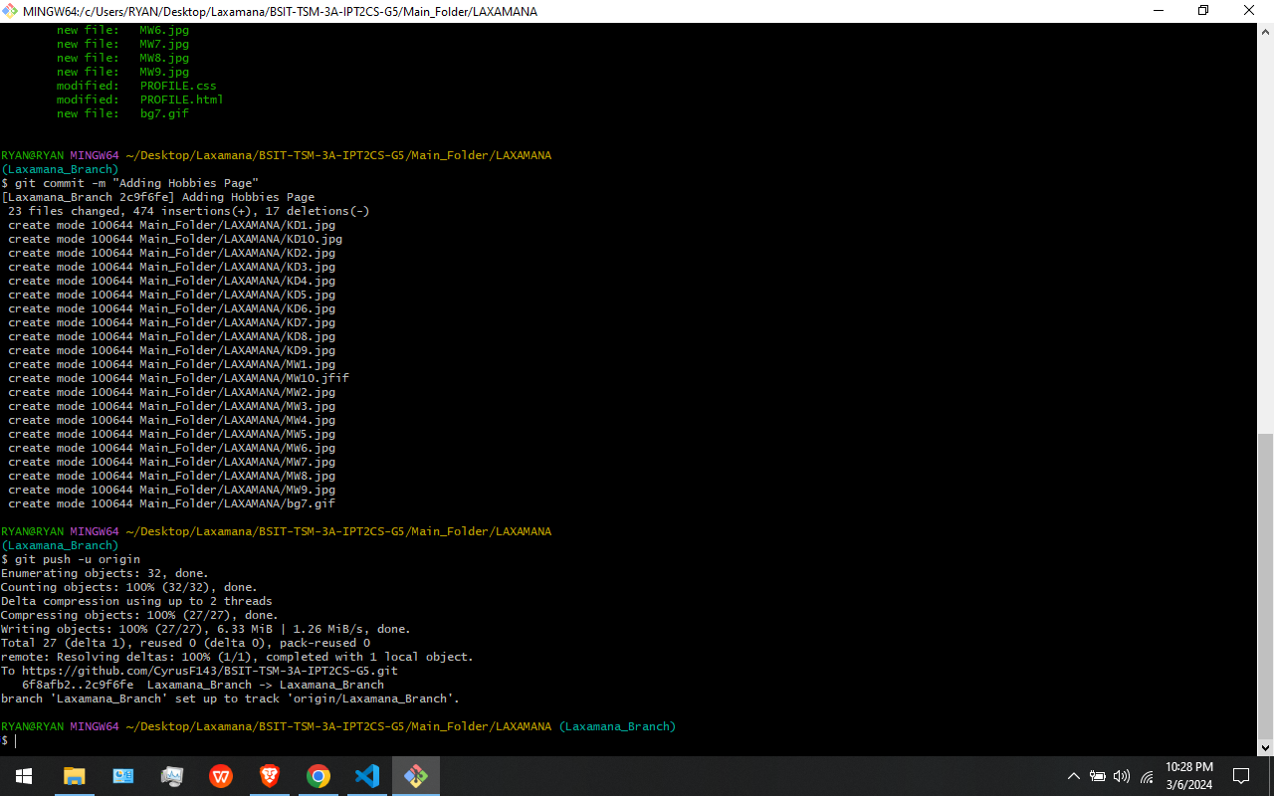

In This Figure: These are my Git Push. I use “git push -u origin” command to push my updated html, css, and javascript to the github repository.

**GIT FETCH:** The git fetch command downloads commits, files, and refs from a remote repository into your local repo. Fetching is what you do when you want to see what everybody else has been working on [15].

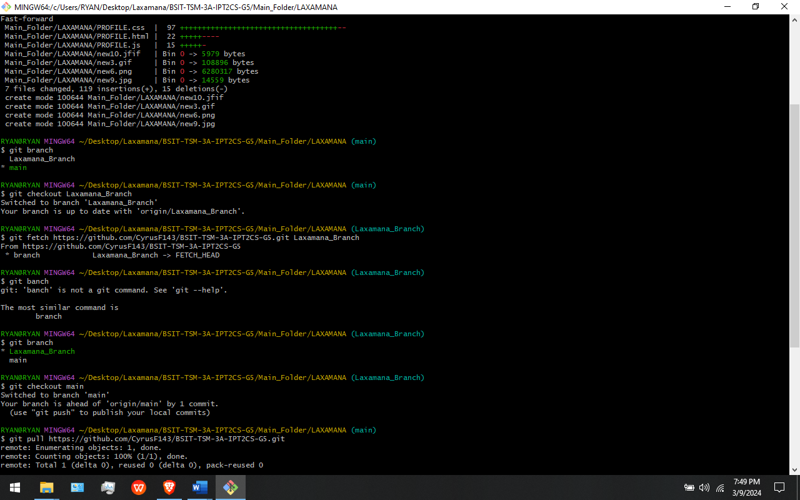

In This Figure: I use the command “git fetch” to downloads all my commits, files from the remote repository into my local repository.

**GIT MERGE:** Merging is Git's way of putting a forked history back together again. The git merge command lets you take the independent lines of development created by git branch and integrate them into a single branch [16].

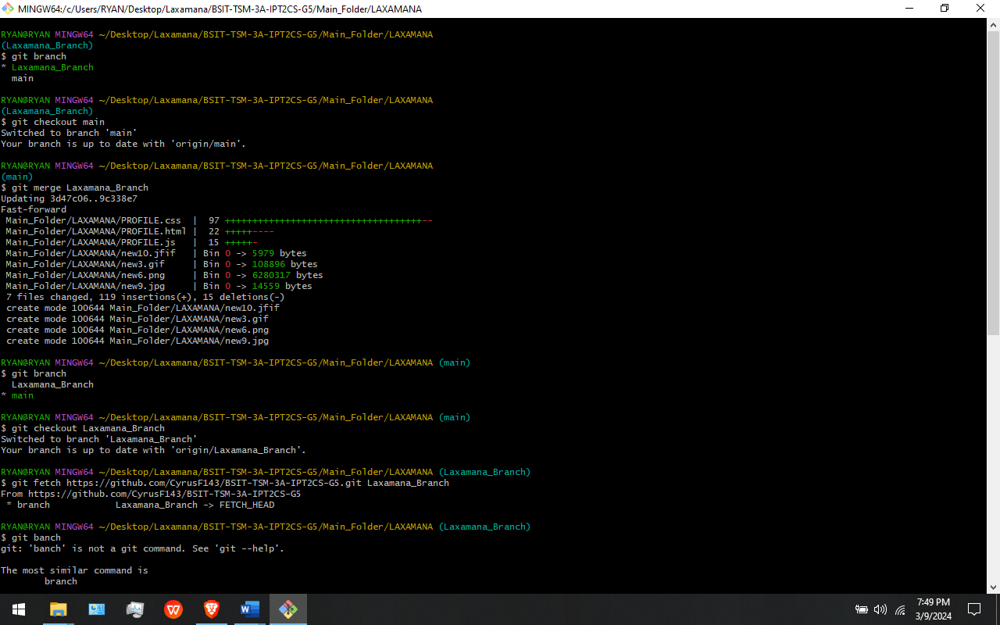

In This Figure: I use the command “git merge” to merge my branch into the main branch in the git bash.

**ISSUE:** GitHub Issues are items you can create in a repository to plan, discuss and track work [13].

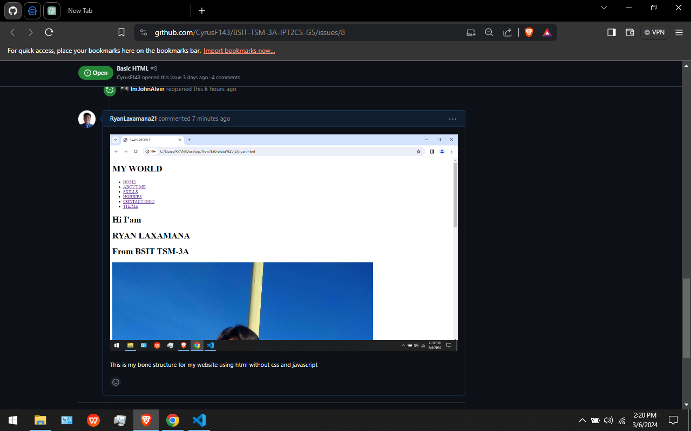

In This Figure: One of our issues is our HTML file without CSS for design and JAVASCIPT.

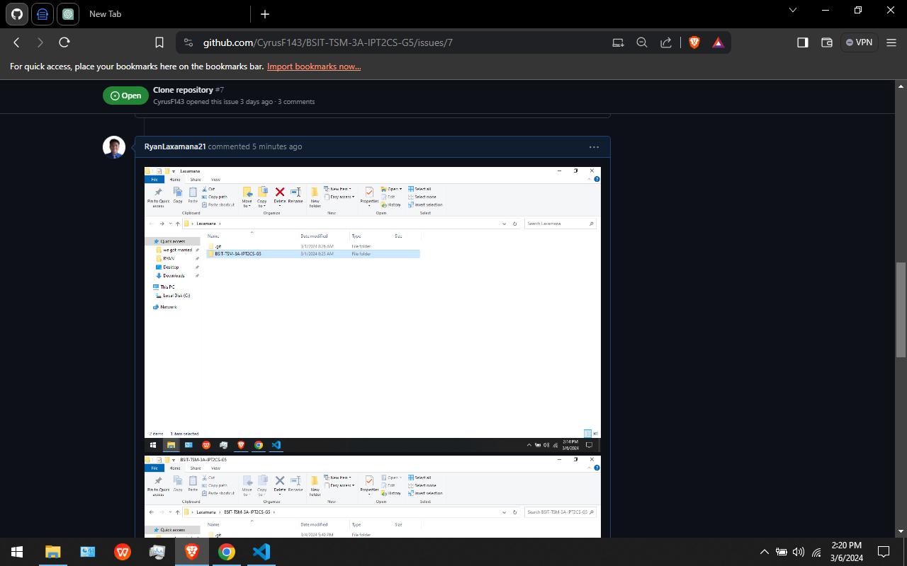

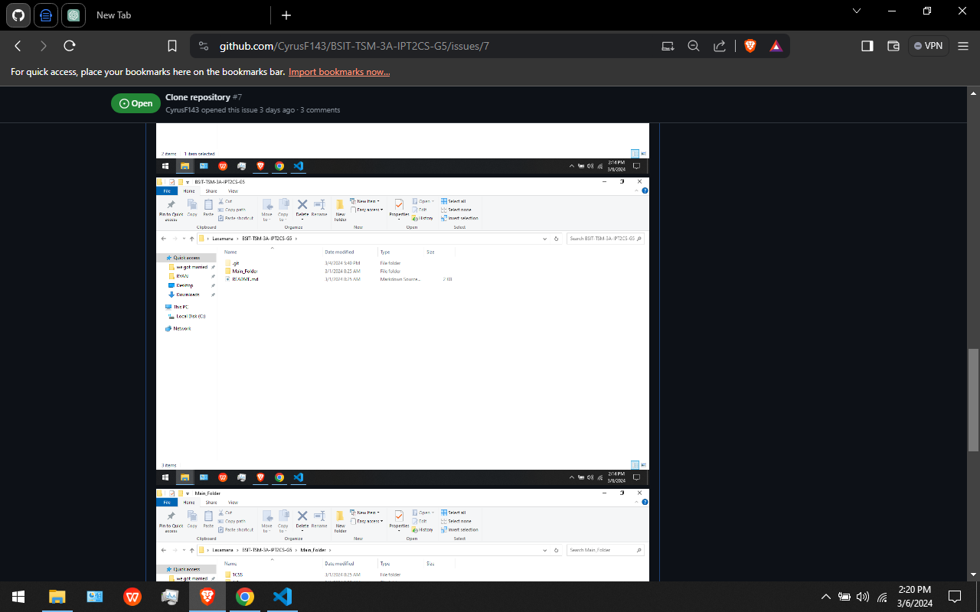

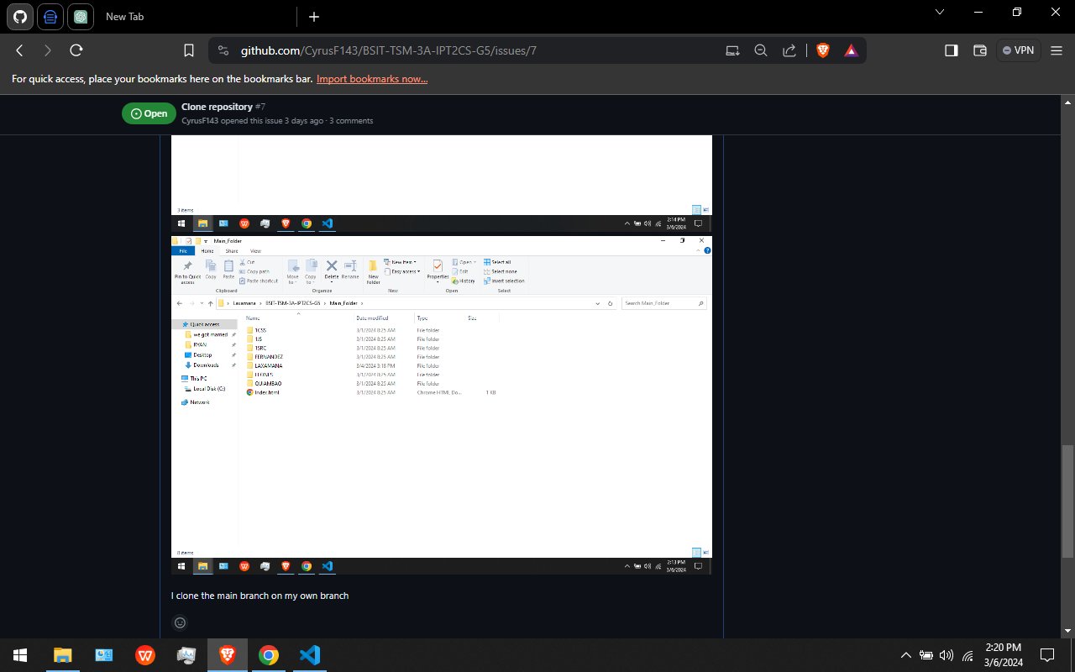

In This Figure: Another one of our issues that is already closed is the cloning of the repository on git bash.

**PULL REQUEST:** A pull request is a proposal to merge a set of changes from one branch into another. In a pull request, collaborators can review and discuss the proposed set of changes before they integrate the changes into the main codebase.

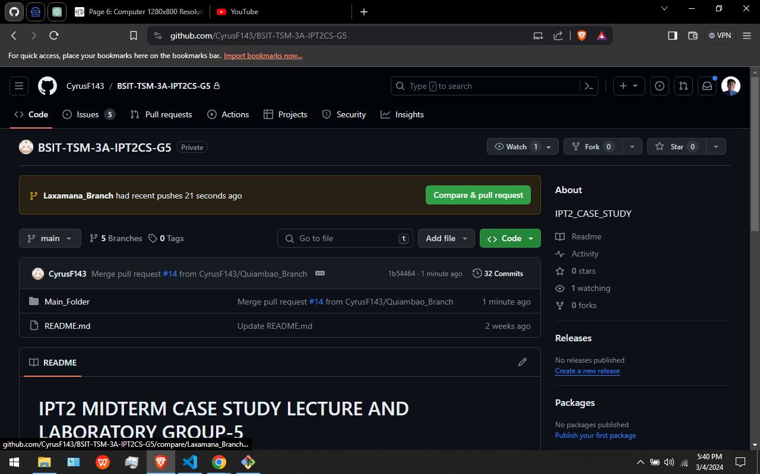

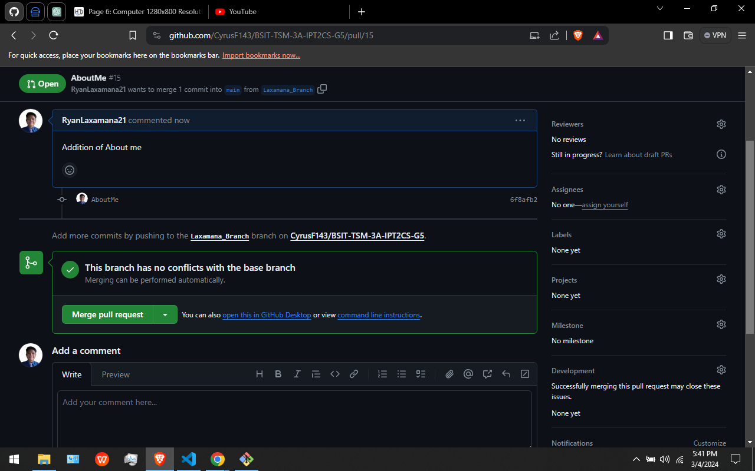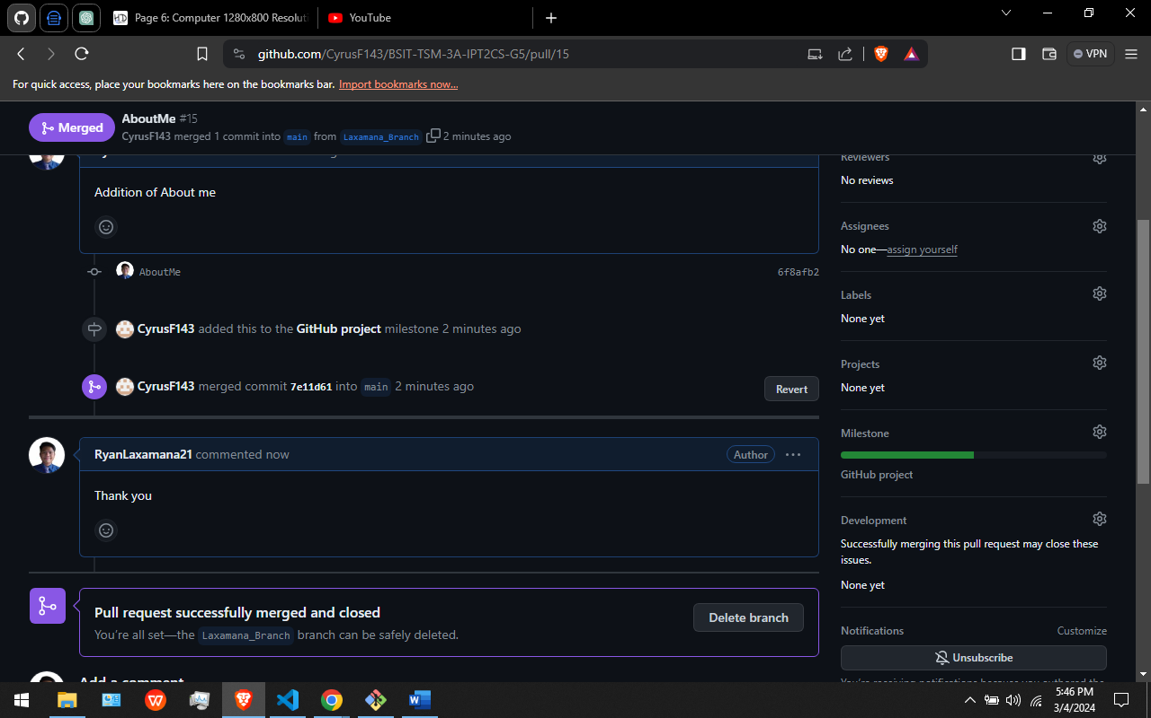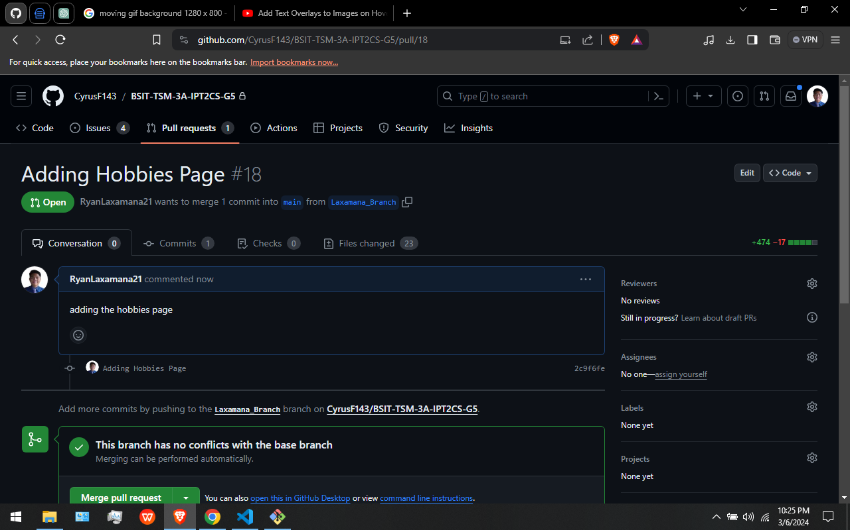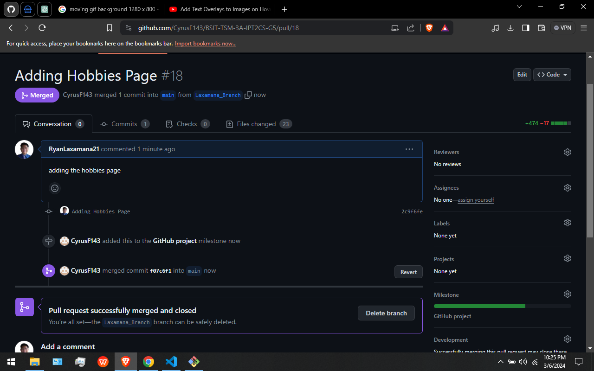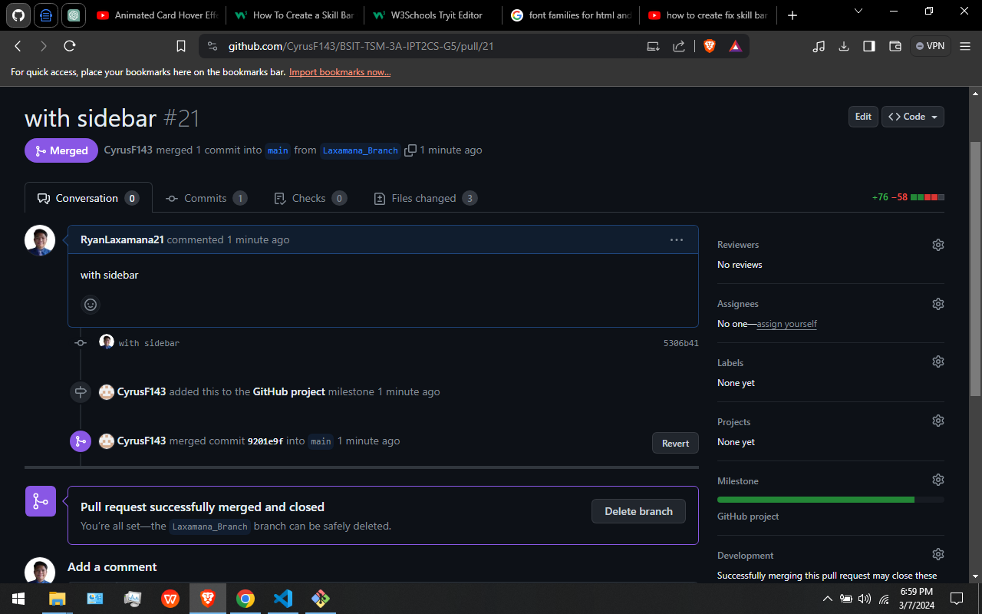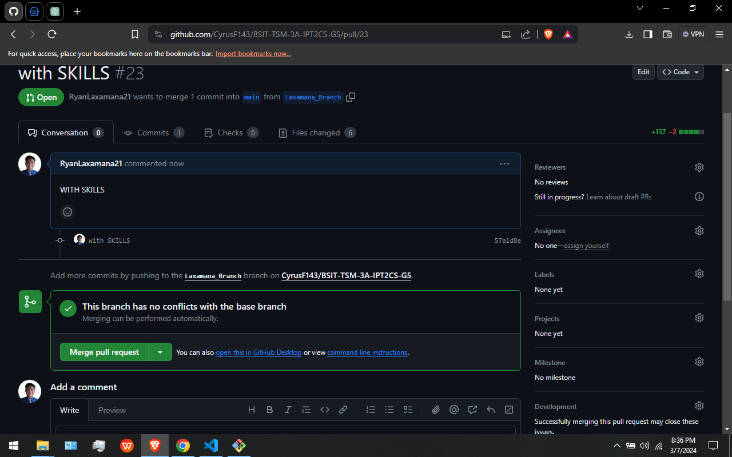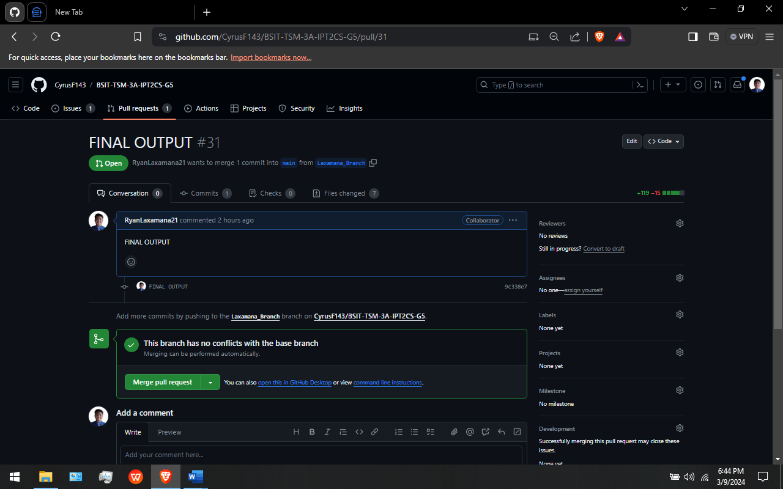

In This Figures: These are my pull requests. After I create a pull request I wait for our leader to reply on my pull request and also to merge my pull request.

**MILESTONE:** You can use milestones to track progress on groups of issues or pull requests in a repository. When you create a milestone, you can associate it with issues and pull requests. To better manage your project, you can view details about your milestone [11].



In This Figure: This is our Milestone Created by our leader. We members can access and look for it anytime.

**BRANCH:** Git branches are effectively a pointer to a snapshot of your changes. When you want to add a new feature or fix a bug—no matter how big or how small—you spawn a new branch to encapsulate your changes. [5]



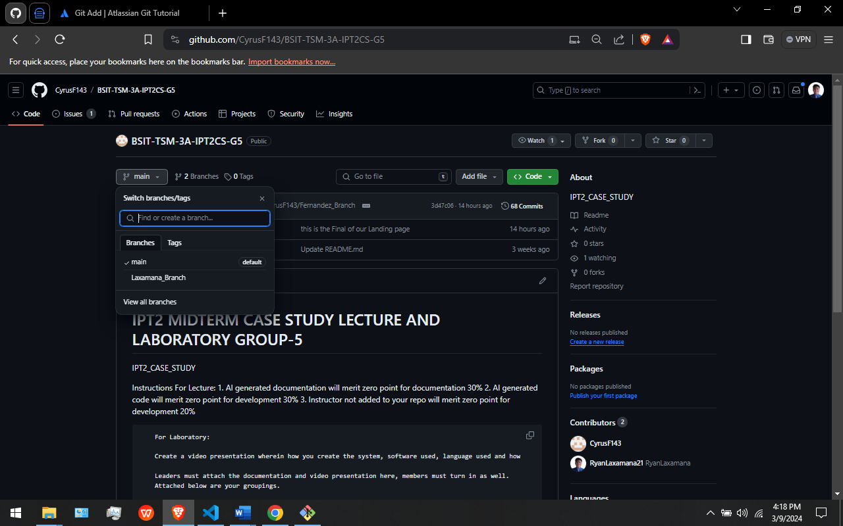

In This Figures: I created my Branch using gitbash Then adding, committing and pushing it on our github repository.

**CREATING MY PROFILE WEBSITE**

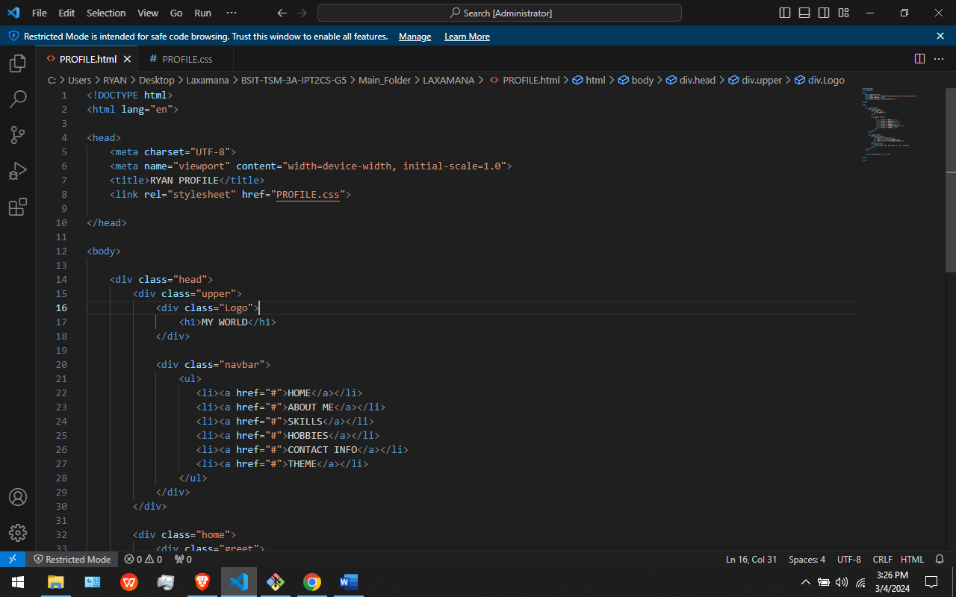

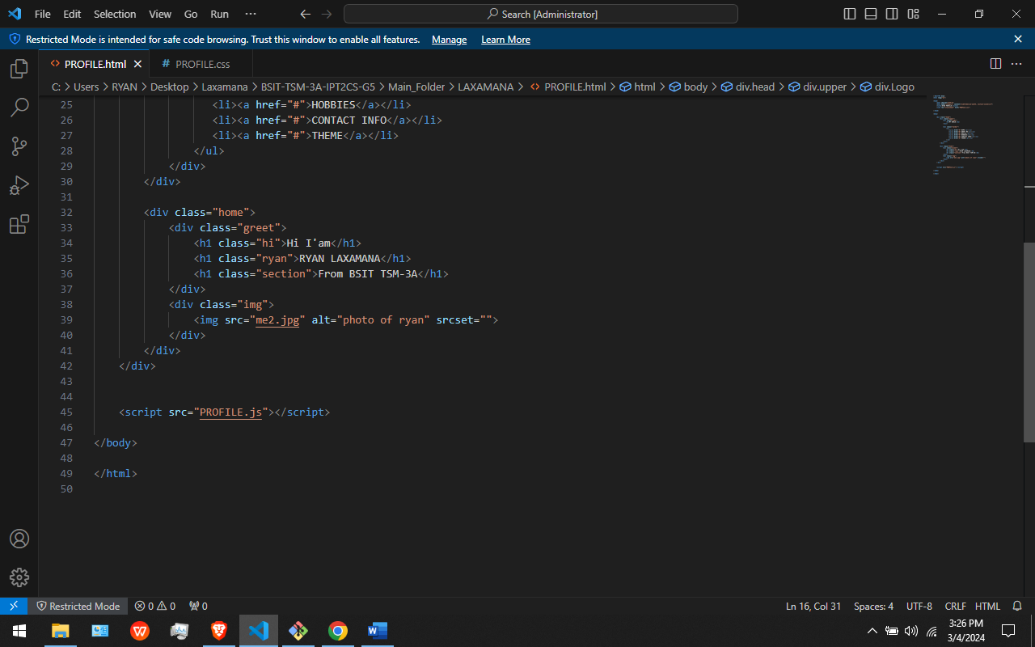

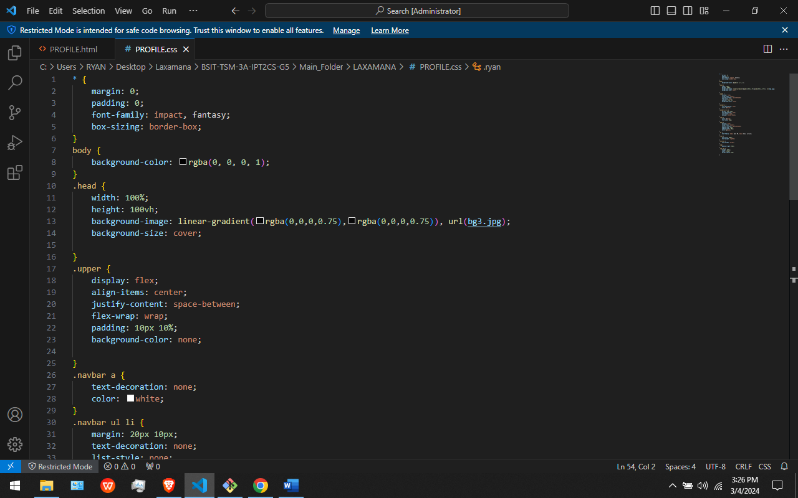

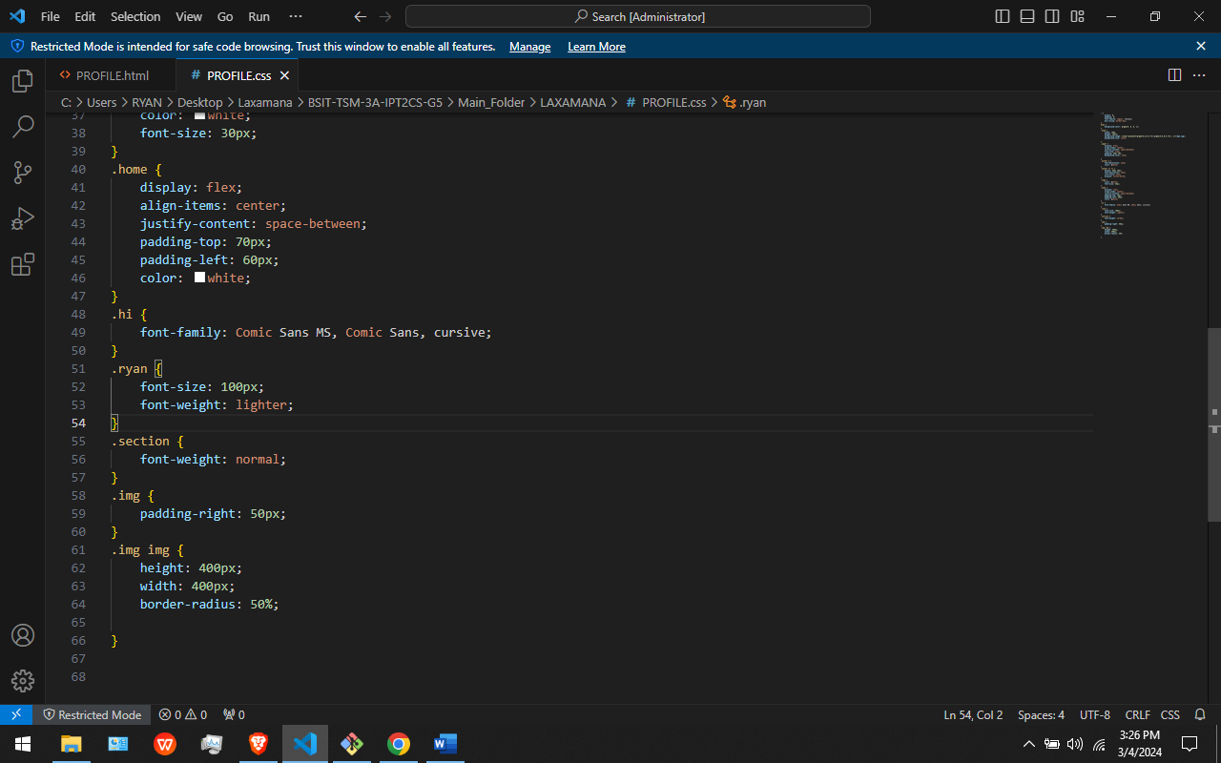

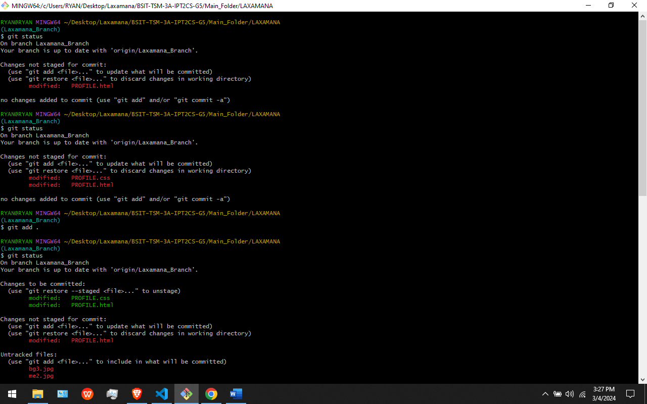



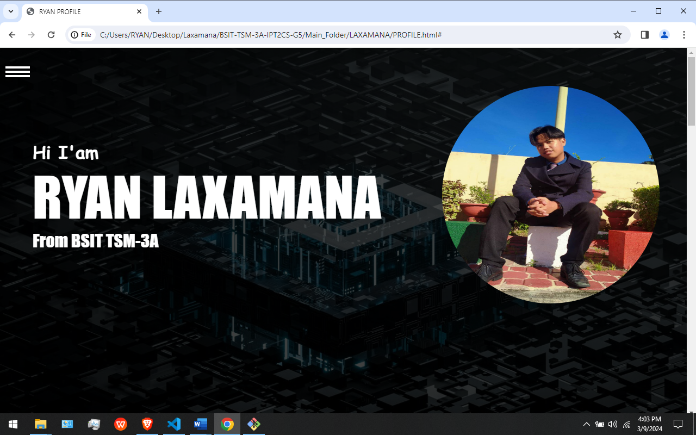

In This Figures: I Created My Greeting page using HTML and CSS. I also Add, Commit and Pushed the Greeting page I created using Git Add, Git Commit, Git Push commands. The git add command adds a change in the working directory to the staging area. It tells Git that you want to include updates to a particular file in the next commit. However, git add doesn't really affect the repository in any significant way—changes are not actually recorded until you run git commit [12]. A commit is the Git equivalent of a "save". Traditional saving should be thought of as a file system operation that is used to overwrite an existing file or write a new file. Alternatively, Git committing is an operation that acts upon a collection of files and directories [12]. git push origin will push the current branch to the branch of the matching name in the remote repository. [7]

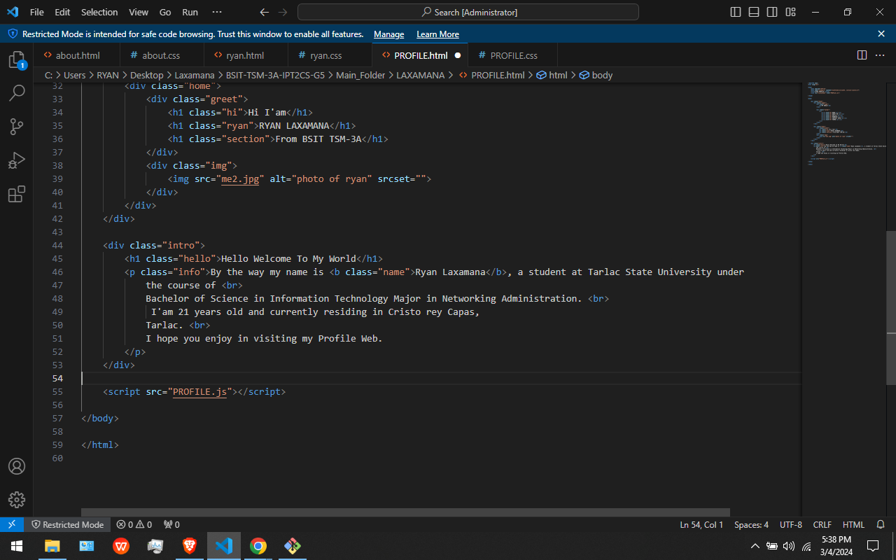

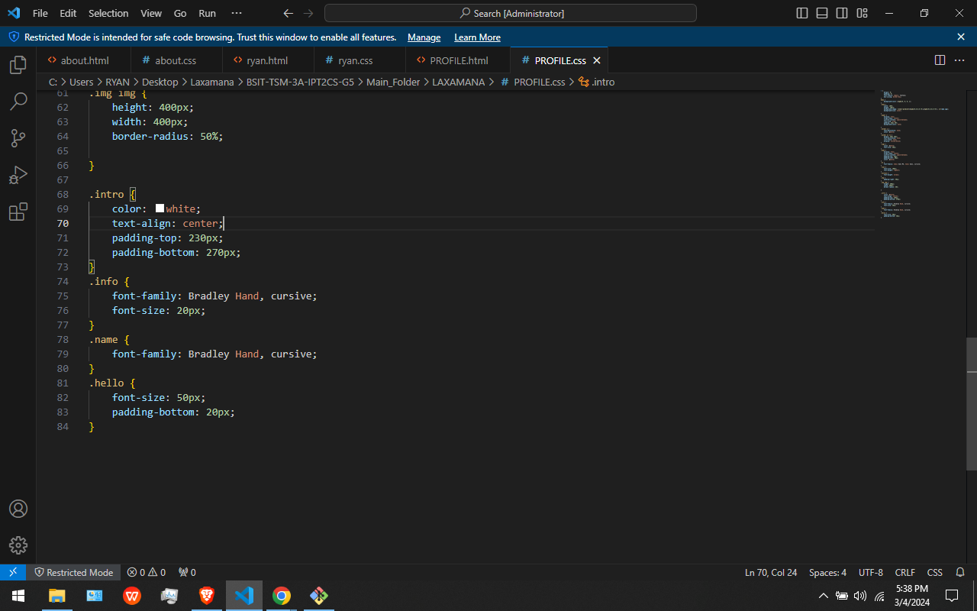





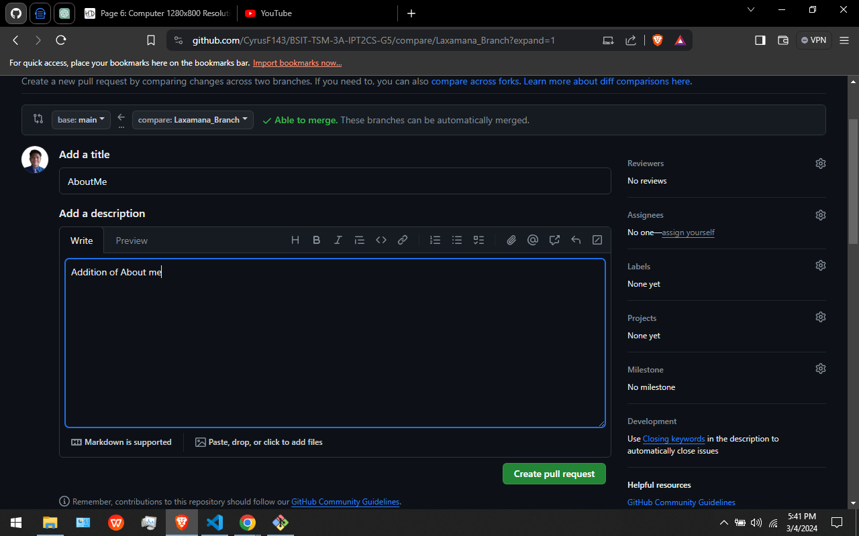



In this Figure. I Add the About me Page in the website. After that I Add it using Git add the commit it using Git commit Then push it using git push command. After that I Use github to pull request and merge the pull request.

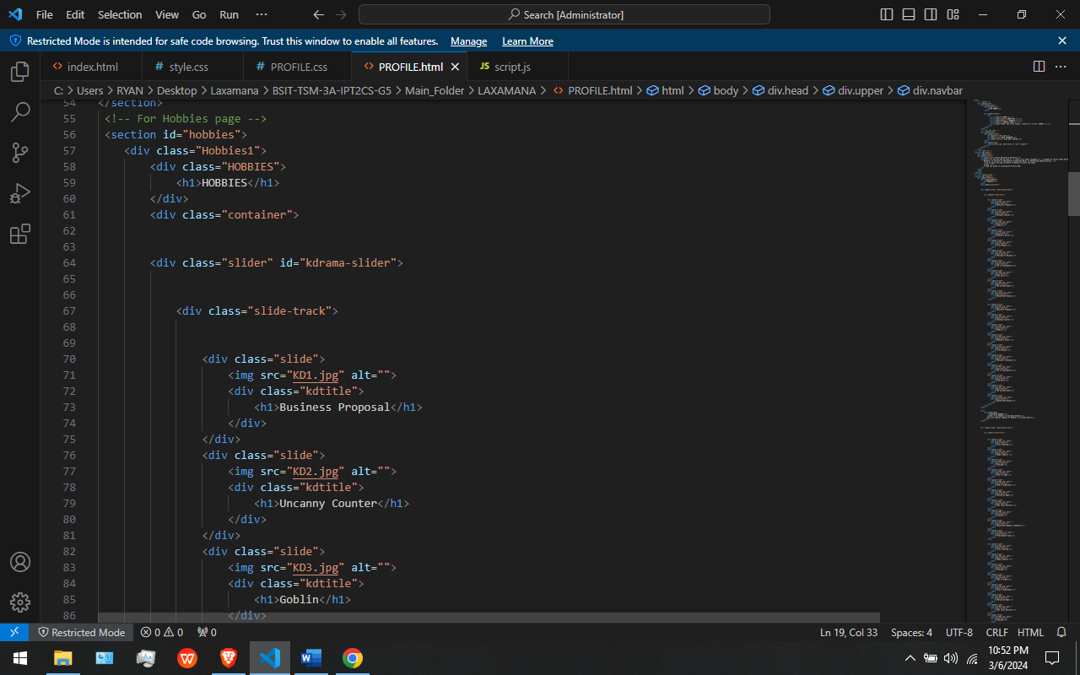

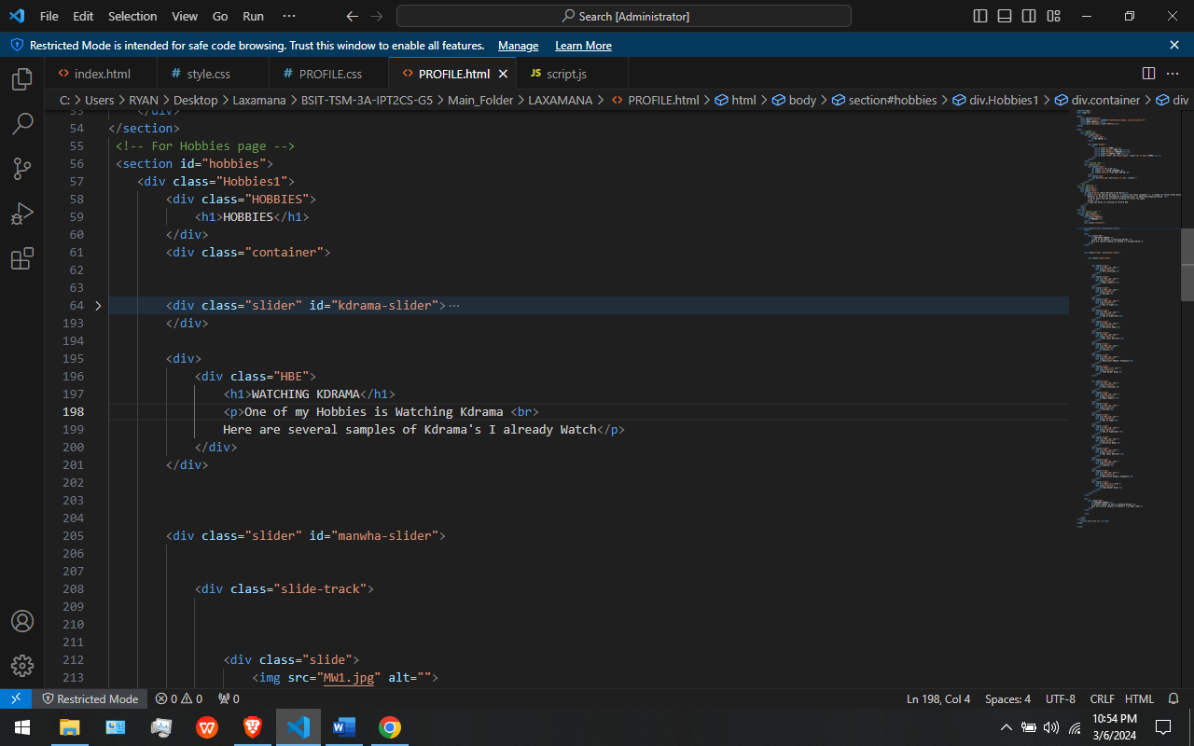

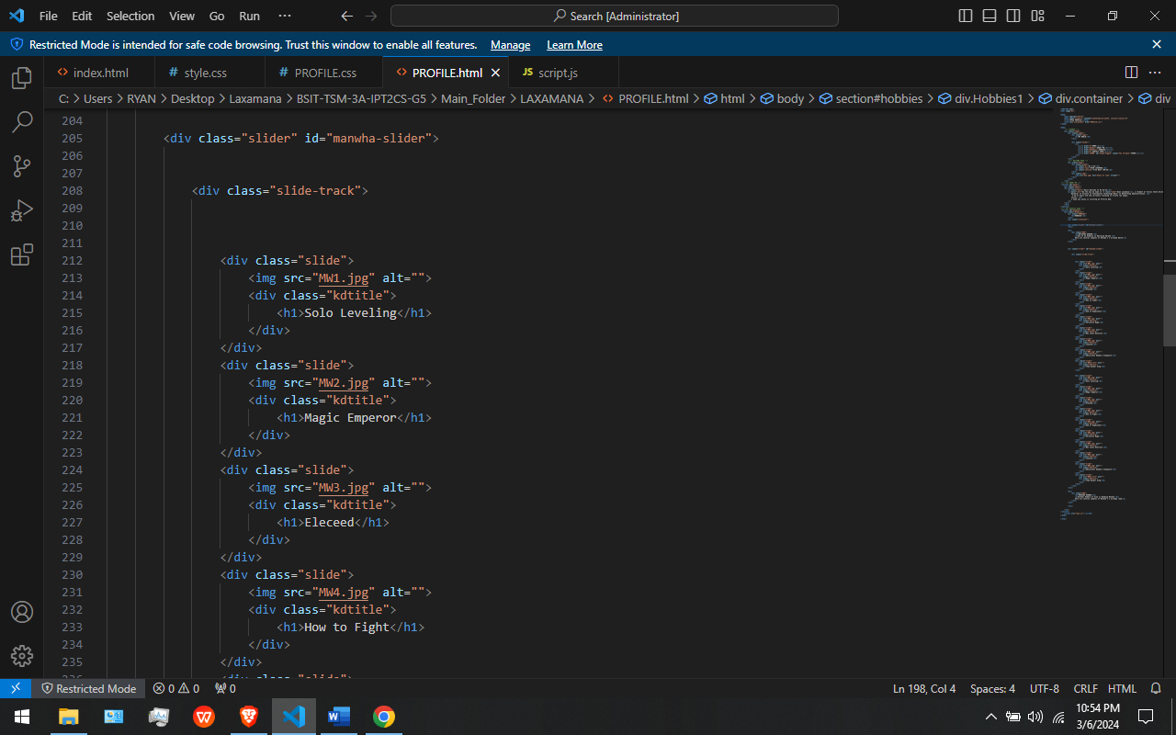

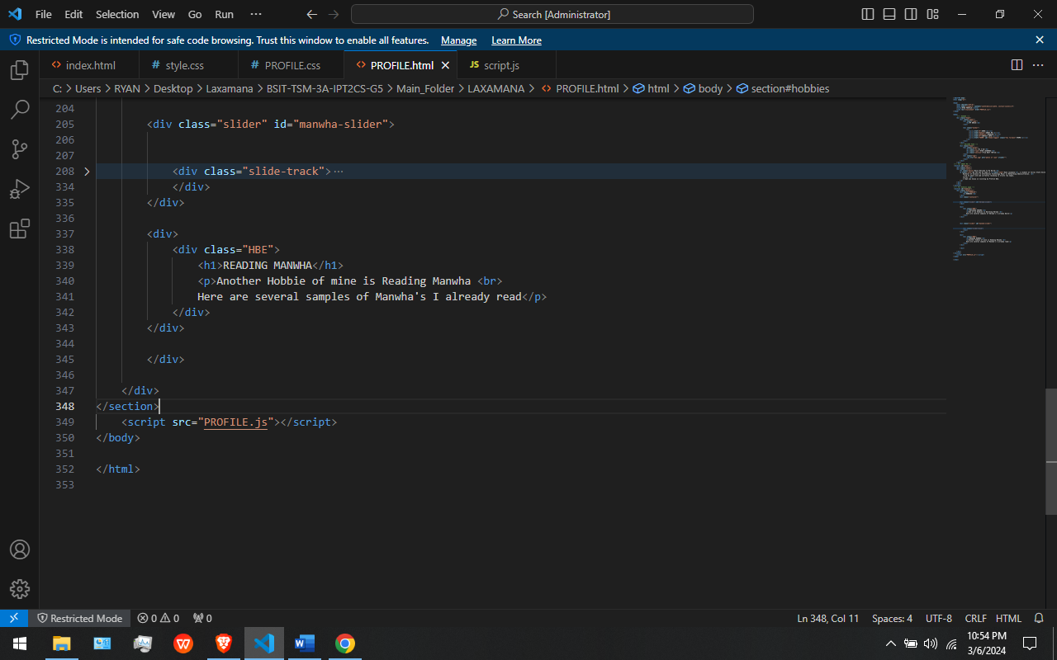

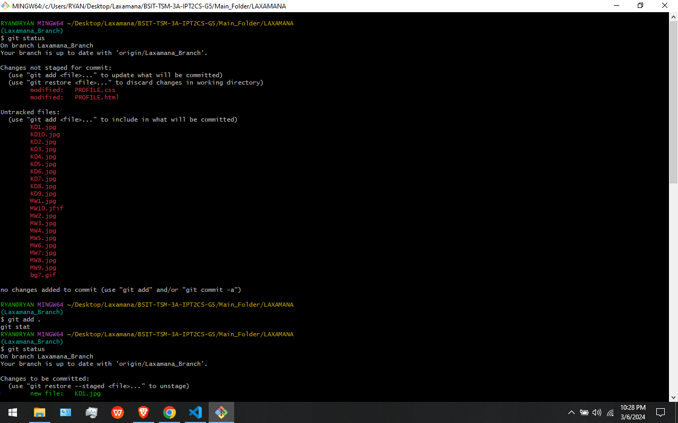

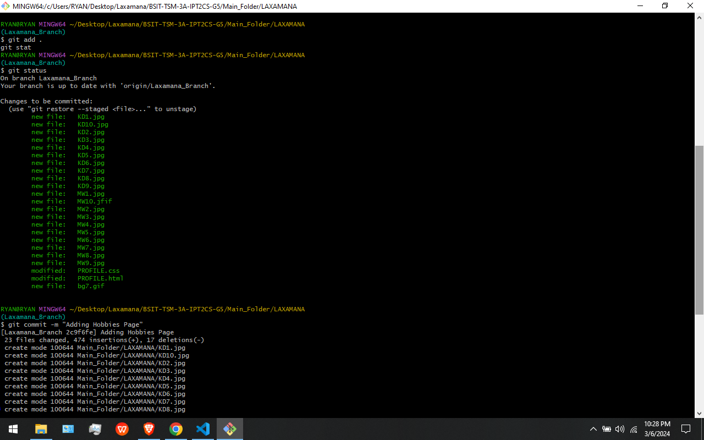



In This Figures: This is where I add the Hobbies page in my profile website where some of my hobbies are being stated. I use “git add”, “git commit”, and “git push” to add, commit, and push my updates in the git hub repository.

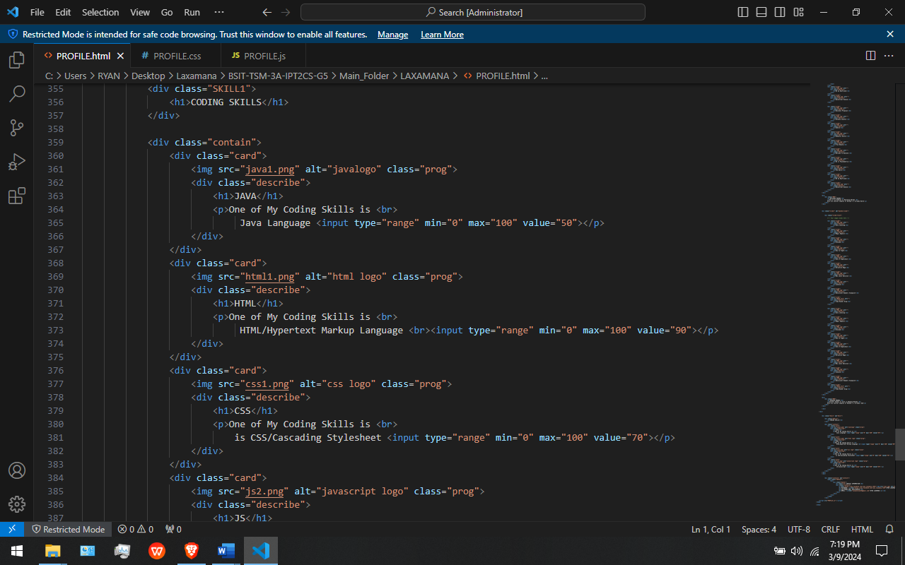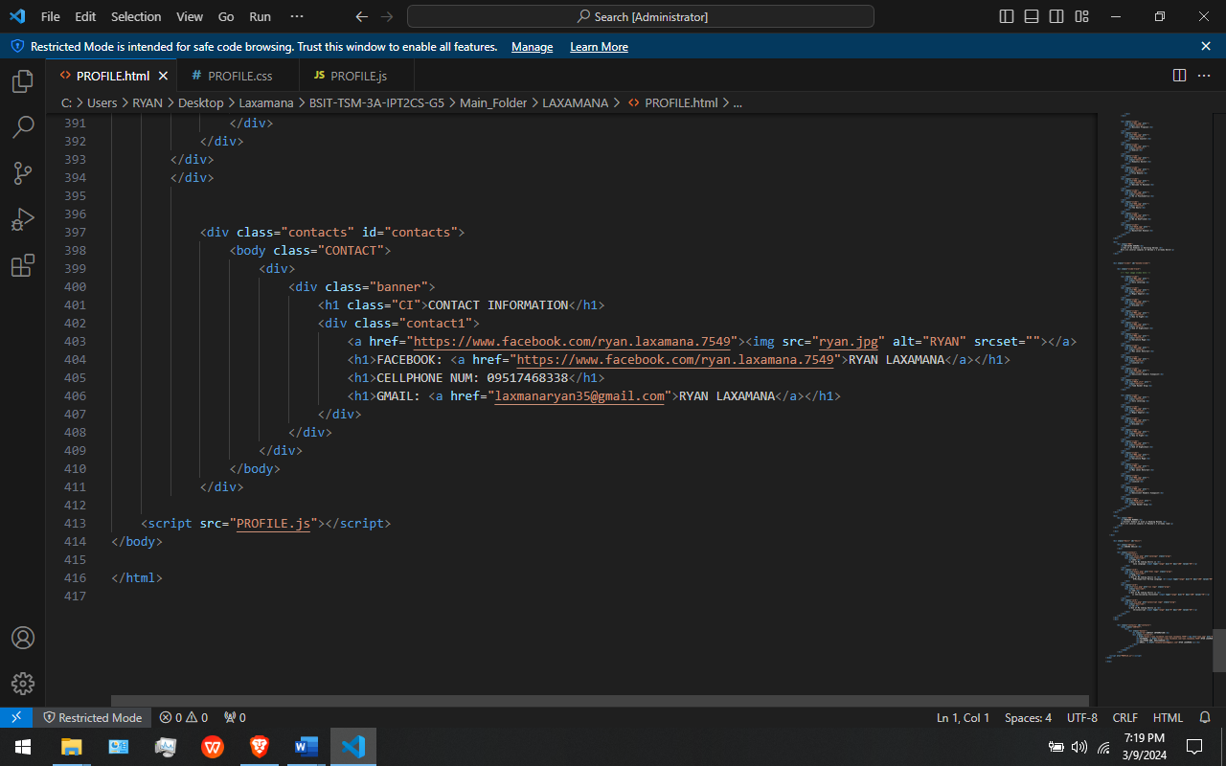

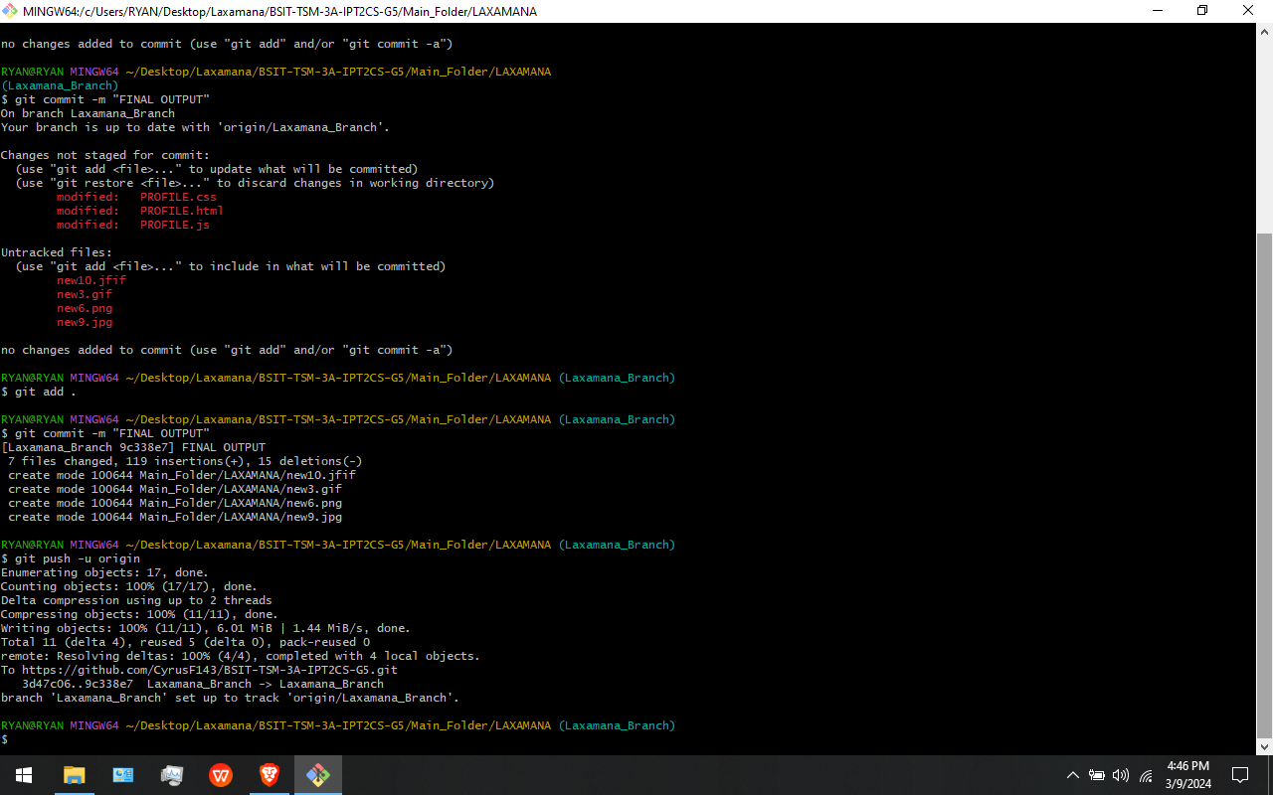

In This Figures: In this part I add the Skills and Contact information page in my profile web page. I use git add, git commit, and git push to push my updates to the github repository.

**MY FINAL PROFILE WEB PAGE OUTPUT**

**DARK THEME/MAIN THEME**

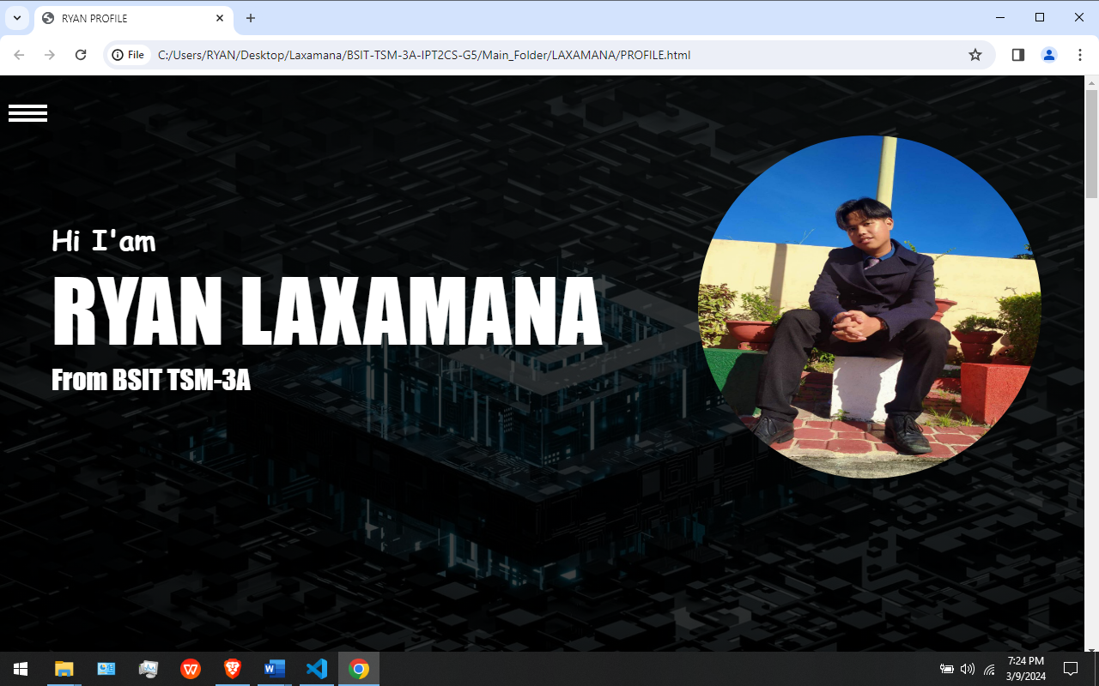

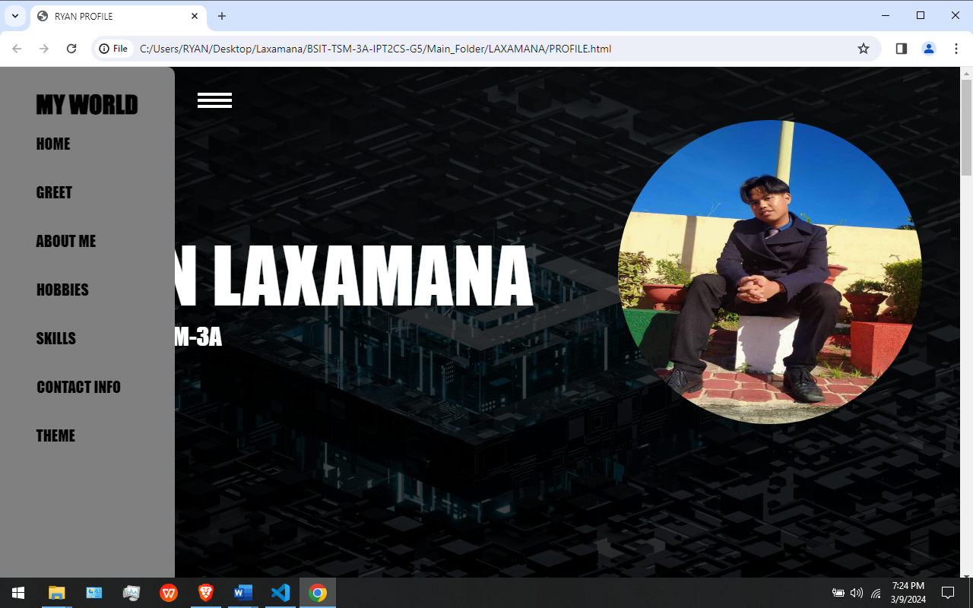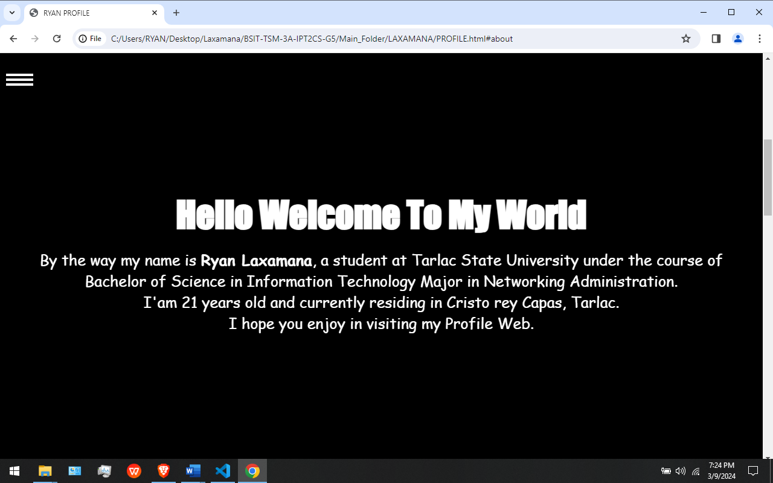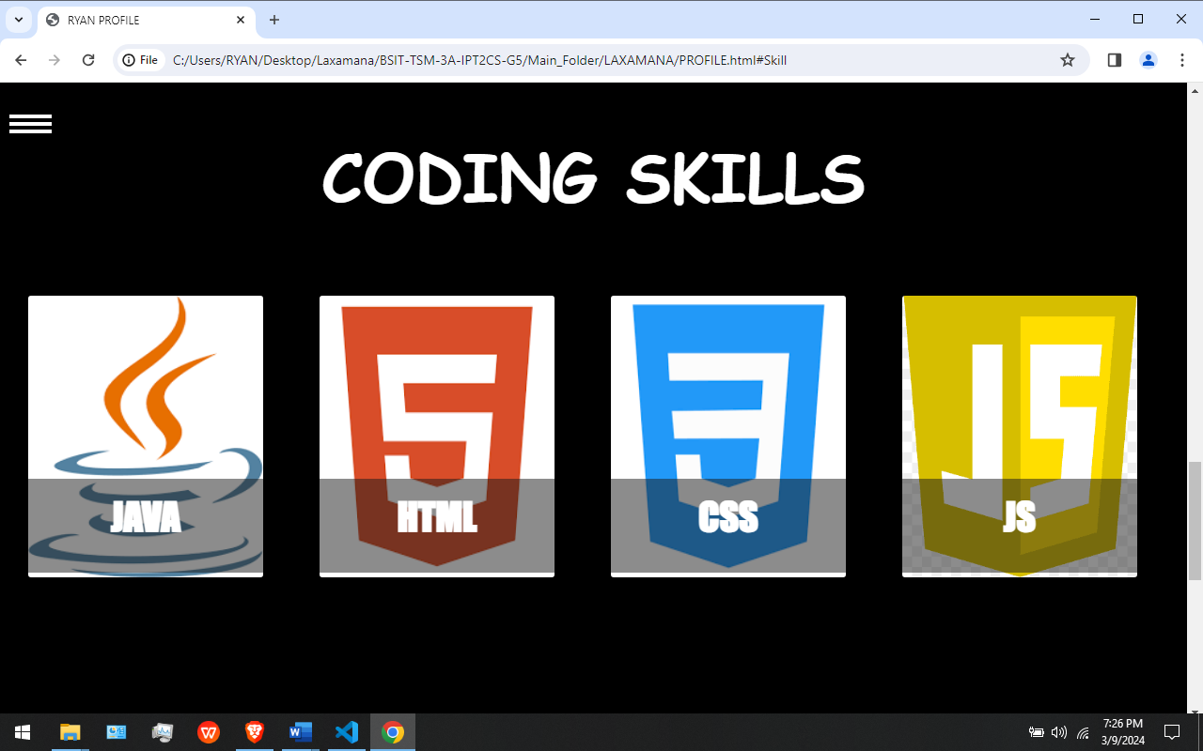

**LIGHT THEME/SUB THEME**

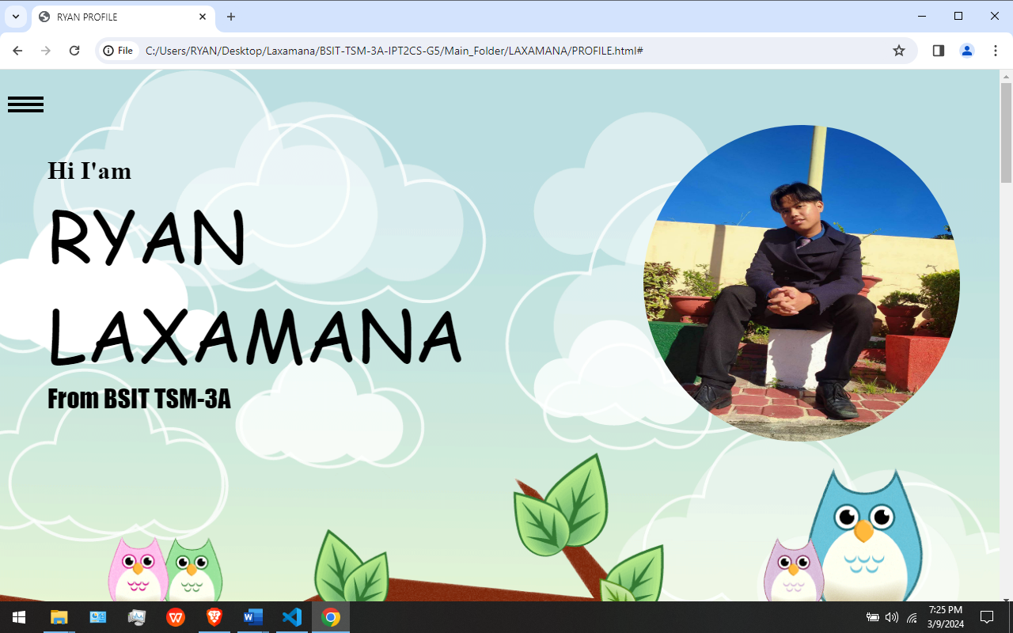

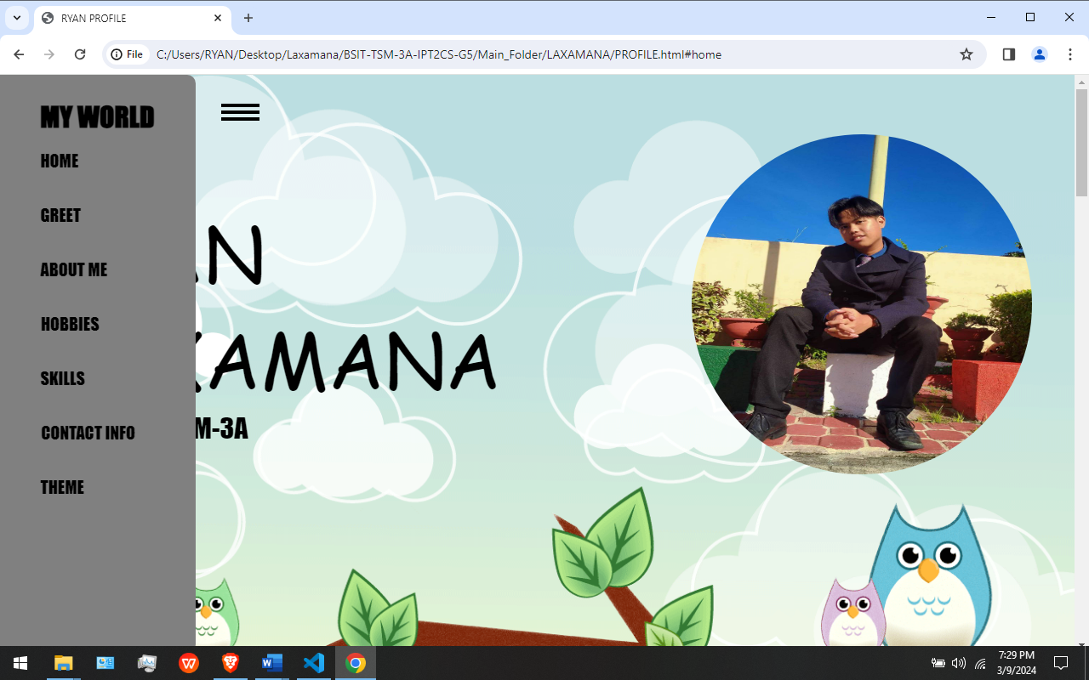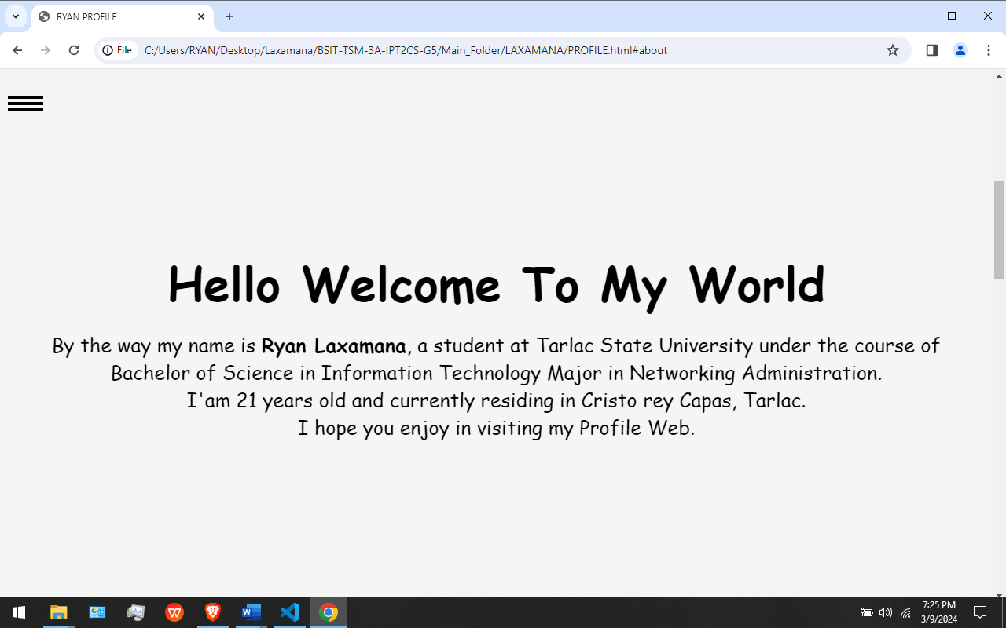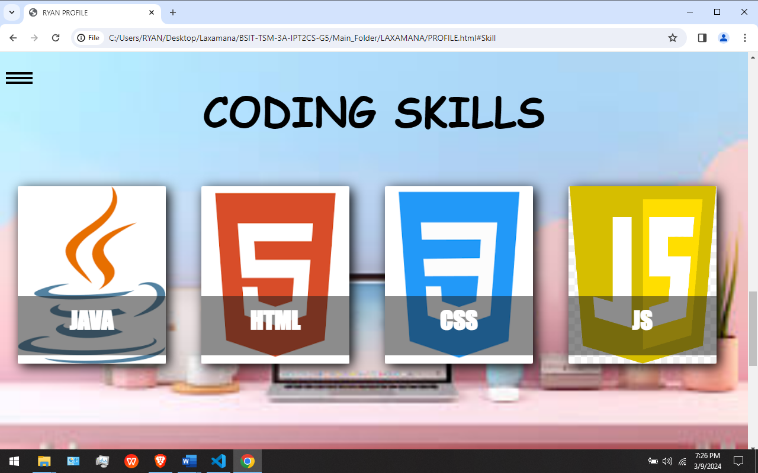

# **References**

|  |  |
| --- | --- |
| [1] | "About repositories," GitHub Docs, [Online]. Available: https://docs.github.com/en/repositories/creating-and-managing-repositories/about-repositories. [Accessed 3 3 2024]. |
| [2] | "About milestones," GitHub Docs, [Online]. Available: https://docs.github.com/en/issues/using-labels-and-milestones-to-track-work/about-milestones. [Accessed 3 3 2024]. |
| [3] | "About issues," GitHub Docs, [Online]. Available: https://docs.github.com/en/issues/tracking-your-work-with-issues/about-issues. [Accessed 3 3 2024]. |
| [4] | "--local-branching-on-the-cheap," Git, [Online]. Available: https://git-scm.com/docs/git-clone. [Accessed 3 3 2024]. |
| [5] | "Git Branch," ATLASSIAN, [Online]. Available: https://www.atlassian.com/git/tutorials/using-branches. [Accessed 3 3 2024]. |
| [6] | "--everything-is-local," GIT, [Online]. Available: https://git-scm.com/docs/git-merge. [Accessed 3 3 2024]. |
| [7] | A. Khoo, "Git Push Origin," warp, [Online]. Available: https://www.warp.dev/terminus/understanding-git-push-origin#:~:text=git%20push%20origin%20is%20a,a%20remote%20repository%20(origin).&text=origin%20is%20the%20conventional%20shorthand,repository%20provider)%20for%20your%20project.. [Accessed 3 3 2024]. |
| [8] | "Git fetch," ATLASSIAN, [Online]. Available: https://www.atlassian.com/git/tutorials/syncing/git-fetch. [Accessed 3 3 2024]. |
| [9] | "GIT PULL," Atlassian, [Online]. Available: https://www.atlassian.com/git/tutorials/syncing/git-pull#:~:text=The%20git%20pull%20command%20is,Git%2Dbased%20collaboration%20work%20flows.. [Accessed 7 March 2024]. |

[10] "GIT CLONE" ATLASSIAN, [Online]. Available: https://www.atlassian.com/git/tutorials/setting-up-a-repository/git-clone#:~:text=git%20clone%20is%20a%20Git,a%20local%20or%20remote%20repository [Accessed 9 March 2024]

[11] "MILESTONE" GITHUB DOCS, [Online]. Available: https://docs.github.com/en/issues/using-labels-and-milestones-to-track-work/about-milestones [Accessed 9 March 2024]

[12] "GIT ADD & GIT COMMIT" ATLASSIAN, [Online]. Available: https://www.atlassian.com/git/tutorials/saving-changes#:~:text=When%20you're%20ready%20to,a%20commit%20or%20staged%20snapshot. [Accessed 9 March 2024]

[13]"ABOUT ISSUES" GITHUB DOCS, [Online]. Available: https://docs.github.com/en/issues/tracking-your-work-with-issues/about-issues [Accessed 9 March 2024]

[14] "GIT PULL" ATLASSIAN, [Online]. Available: https://www.atlassian.com/git/tutorials/syncing/git-pull#:~:text=The%20git%20pull%20command%20is,Git%2Dbased%20collaboration%20work%20flows. [Accessed 9 March 2024]

[15] "GIT FETCH" ATLASSIAN, [Online]. Available: https://www.atlassian.com/git/tutorials/syncing/git-fetch [Accessed 9 March 2024]

[16] "GIT MERGE" ATLASSIAN, [Online]. Available: https://www.atlassian.com/git/tutorials/using-branches/git-merge [Accessed 9 March 2024]